DEPLOYING NODE.JS APPLICATION ON
ELASTIC BEANSTALK USING CI/CD PIPELINE
+
Project Overview
The objective of this project is to deploy a Node.js web application on AWS
Elastic Beanstalk using a Continuous Integration and Continuous Deployment (CI/CD) pipeline. The pipeline automatically builds and deploys the application whenever code changes are pushed to the GitHub repository.
Technologies Used
- Node.js
- Express.js
- AWS Elastic Beanstalk
- AWS IAM
- AWS S3 (used internally by Elastic Beanstalk)
- AWS EC2 (created by Elastic Beanstalk)
- Docker (optional if containerized deployment was used)

STEP BY STEP PROCESS :
Here are the step by step process for deploying node.js applications on elastic beanstalk using pipeline.
After logging in, type Elastic Beanstalk in the AWS search bar.
Click Elastic Beanstalk from the search results.
Click the Create Application button.
This starts the process of creating a new application environment.
In the application name field, enter your project name. Under platform, choose Node.js . AWS automaticcaly selects the recommended platform version.

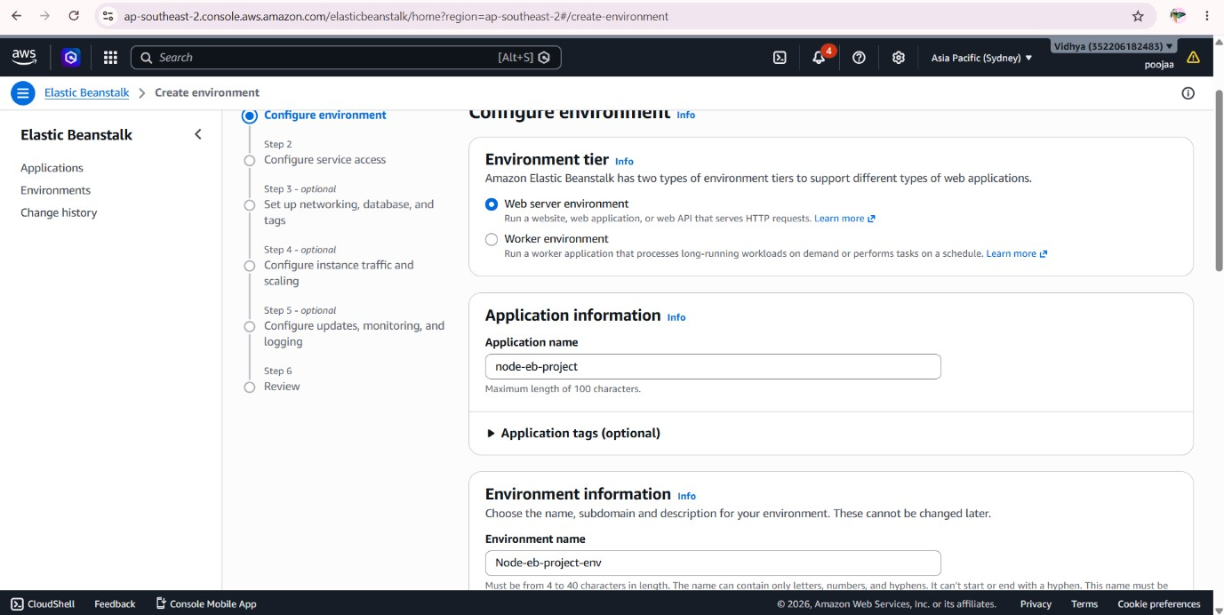

Select AWS service as the trusted entity and choose the appropriate use case (Elastic Beanstalk or EC2). Then click next.

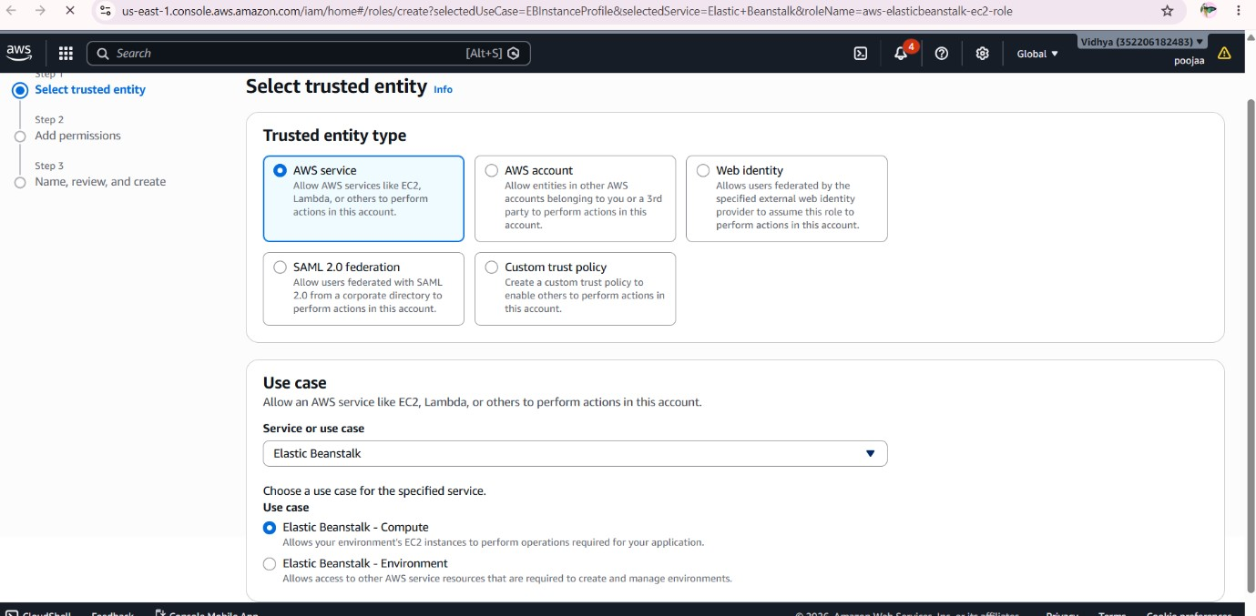

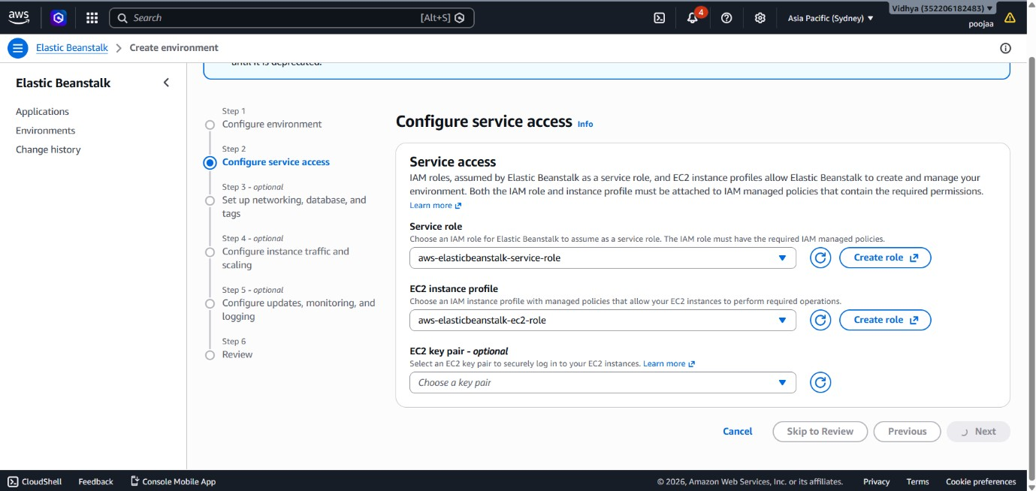

Open the Configure Service Access page.Select the Service Role for Elastic Beanstalk.Select the EC2 Instance Profile.Keep the default permissions (or choose the required IAM roles). Click Next to continue.

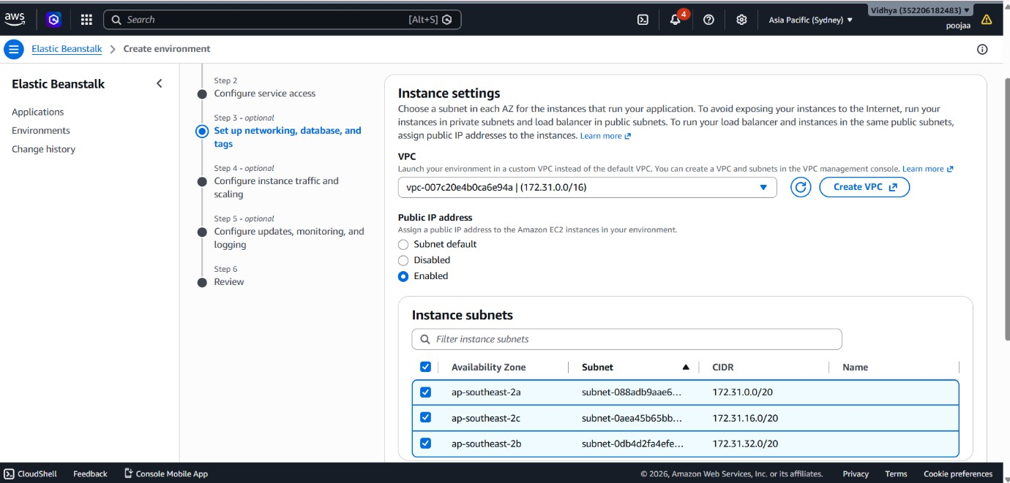
For configure the instances type, traffic settings, and scaling options.Keep the default configuration for a single instances.Then select the EC2 security group and click Next.

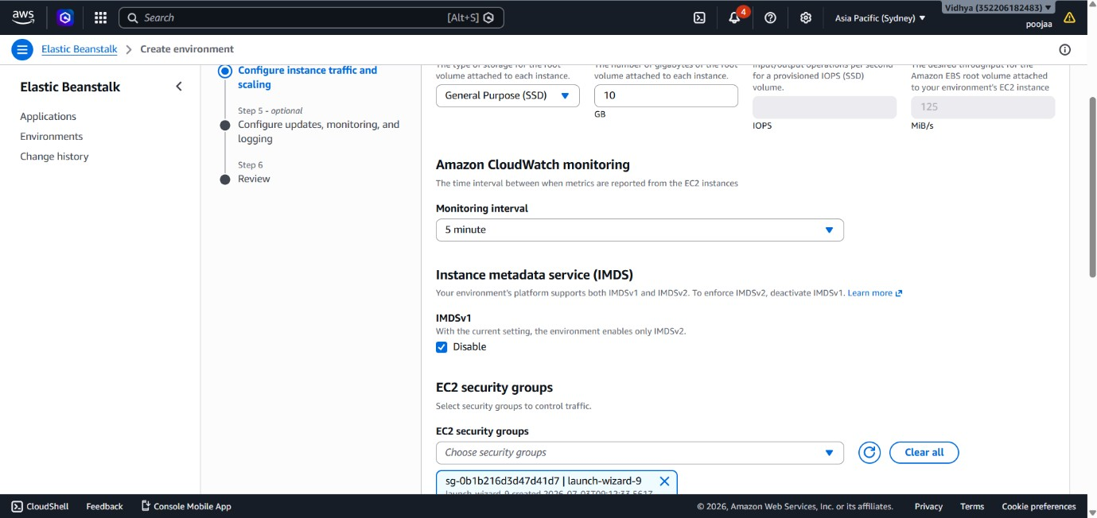
After completing all the process, the environment health should be in green.

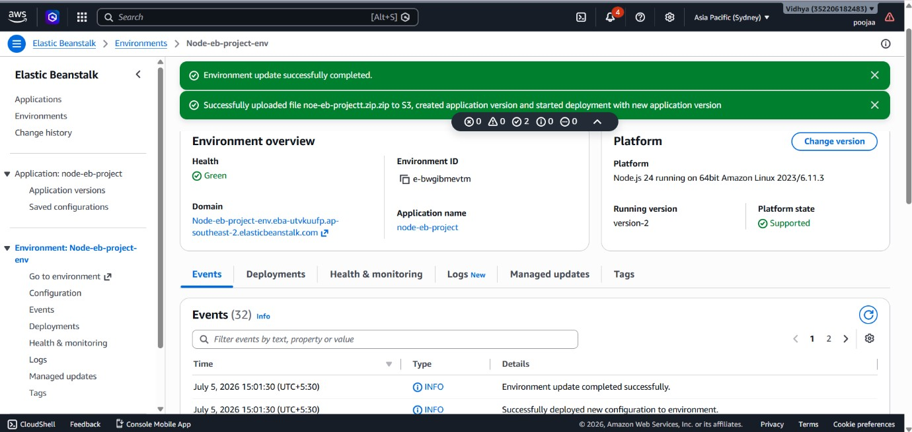
In the above screenshot, we can see the environment created successfully.

STEP FOR CREATING PIPELINE :
Step 1: Open AWS CodePipeline
Sign in to the AWS Management Console. In the search bar, type CodePipeline and open the service.
Purpose: Opens the AWS CodePipeline service to create a CI/CD pipeline.
Step 2: Create Pipeline
Click the Create pipeline button.
Purpose: Starts the pipeline creation process.
Step 3: Enter Pipeline Details Enter the following details:
Pipeline Name: pandu-pipeline
Service Role: Create a new service role or use the default role.
Click Next.
Purpose: Creates a unique pipeline and assigns permissions.
Step 4: Choose Source Provider
Under Source Provider, select:
GitHub (Version 2)
Click Connect to GitHub and sign in to your GitHub account.
Purpose: Connects the pipeline to the GitHub repository.
Step 5: Select Repository
Choose:
Repository: Your project repository
Branch: main
Enable Detect changes so the pipeline starts automatically when new code is pushed.
Click Next.
Purpose: Selects the source code repository.
Step 6: Add Build Stage
Choose AWS CodeBuild.
Create a new build project or select an existing one.
Click Next.
Purpose: Builds the application before deployment.
Step 7: Configure Build Project
Enter the build project details.
Select:
Operating System: Amazon Linux
Runtime: Standard Buildspec: buildspec.yml
Save the build project.
Purpose: Configures the build environment.
Step 8: Add Deploy Stage
For the deployment provider, select:
AWS Elastic Beanstalk Choose:
Application Name Environment Name
Click Next.
Purpose: Configures deployment to Elastic Beanstalk.
Step 9: Review Pipeline
Review all the pipeline settings.
Click Create Pipeline.
Purpose: Creates the complete CI/CD pipeline.
Step 10: Execute the Pipeline
The pipeline starts automatically.
Monitor each stage:
Source
Build
Deploy
Wait until all stages show Succeeded.
Purpose: Verifies that the application is built and deployed successfully.
Here,I have uploaded the source, build, deploy ,all the stages are showed successed.
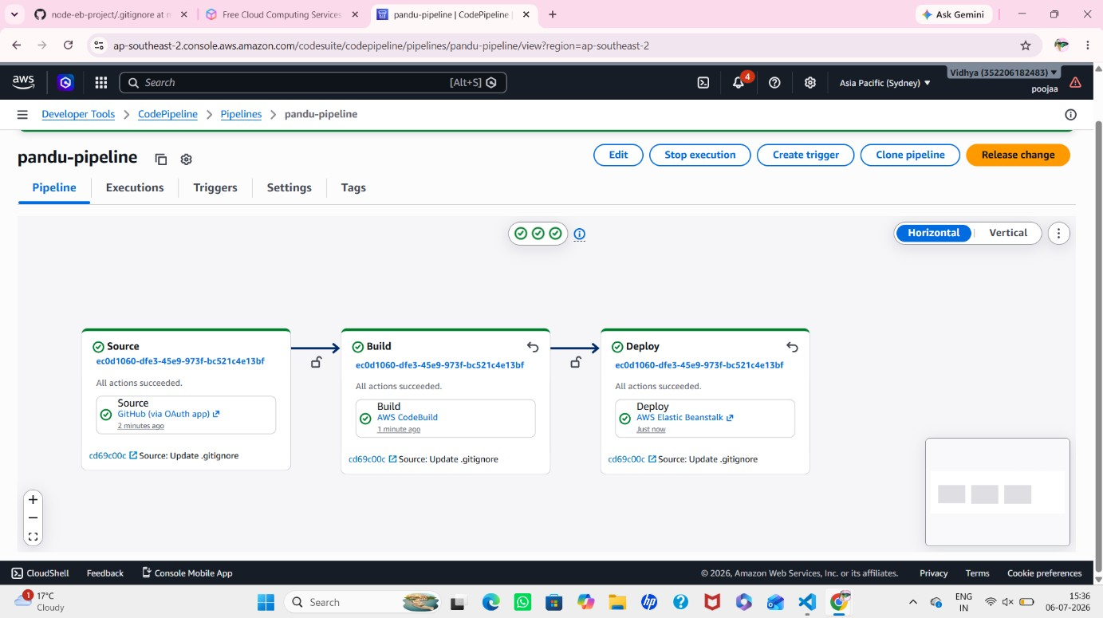
Then, Open the Elastic Beanstalk domain URL.
Verify that the latest version of the application is displayed.
Here , The TravelGo website was successfully deployed. Users can access the application through the generated AWS domain URL, explore travel packages, and book trip online.



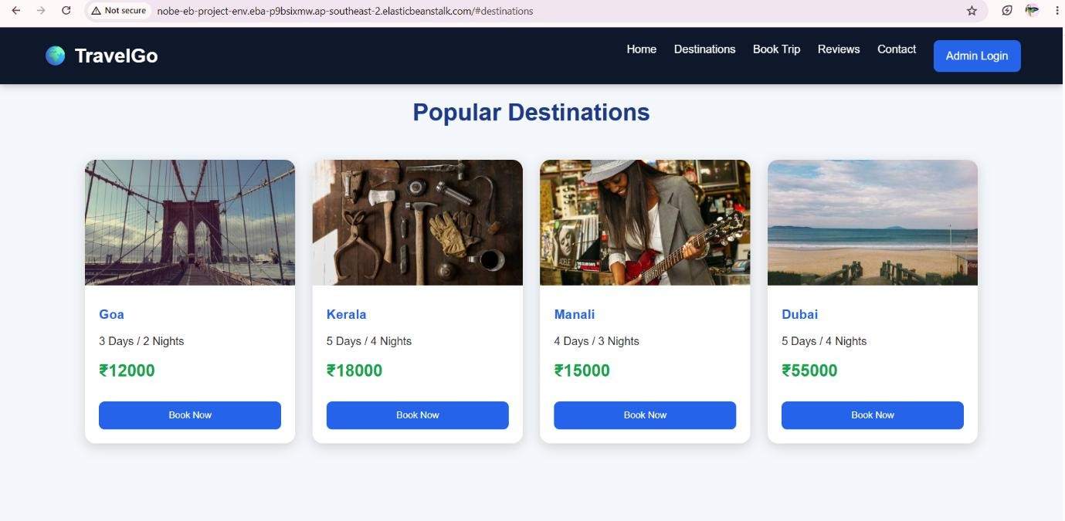
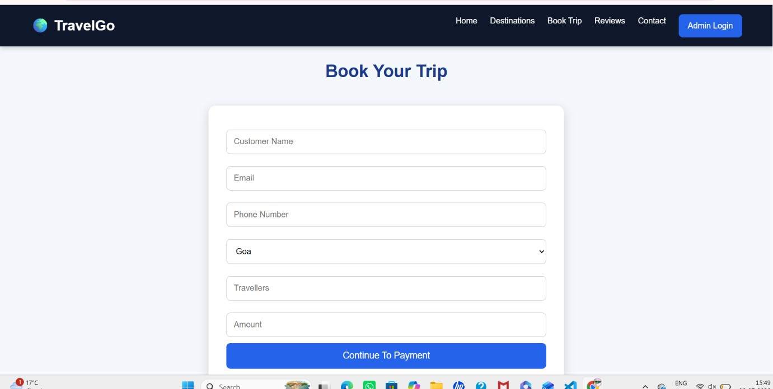

Dockerfile Implementation
Step 1: Install Docker Desktop
Docker Desktop was installed on the Windows system to build and run Docker containers. Docker Engine was started successfully before creating the Docker image.
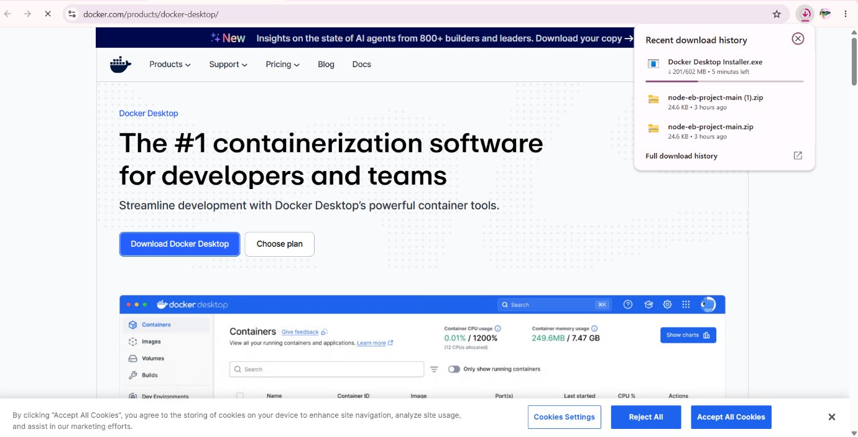

Step 2: Create a Dockerfile
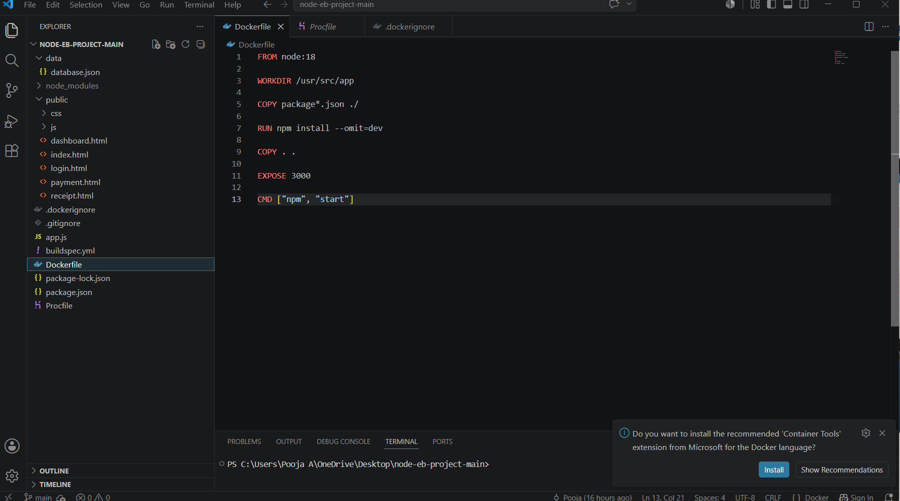
A file named Dockerfile was created in the root directory of the Node.js TravelGo project. This file contains the instructions required to build the Docker image.
Write the Dockerfile
The Dockerfile was configured to:
Use the Node.js base image.
Set the working directory.
Copy the application files.
Install project dependencies using npm install.
Expose port 3000.
Start the application using:
npm start.
Step 3: Create a .dockerignore File
A .dockerignore file was created to exclude unnecessary files such as:
node_modules
.git
.vscode npm-debug.log
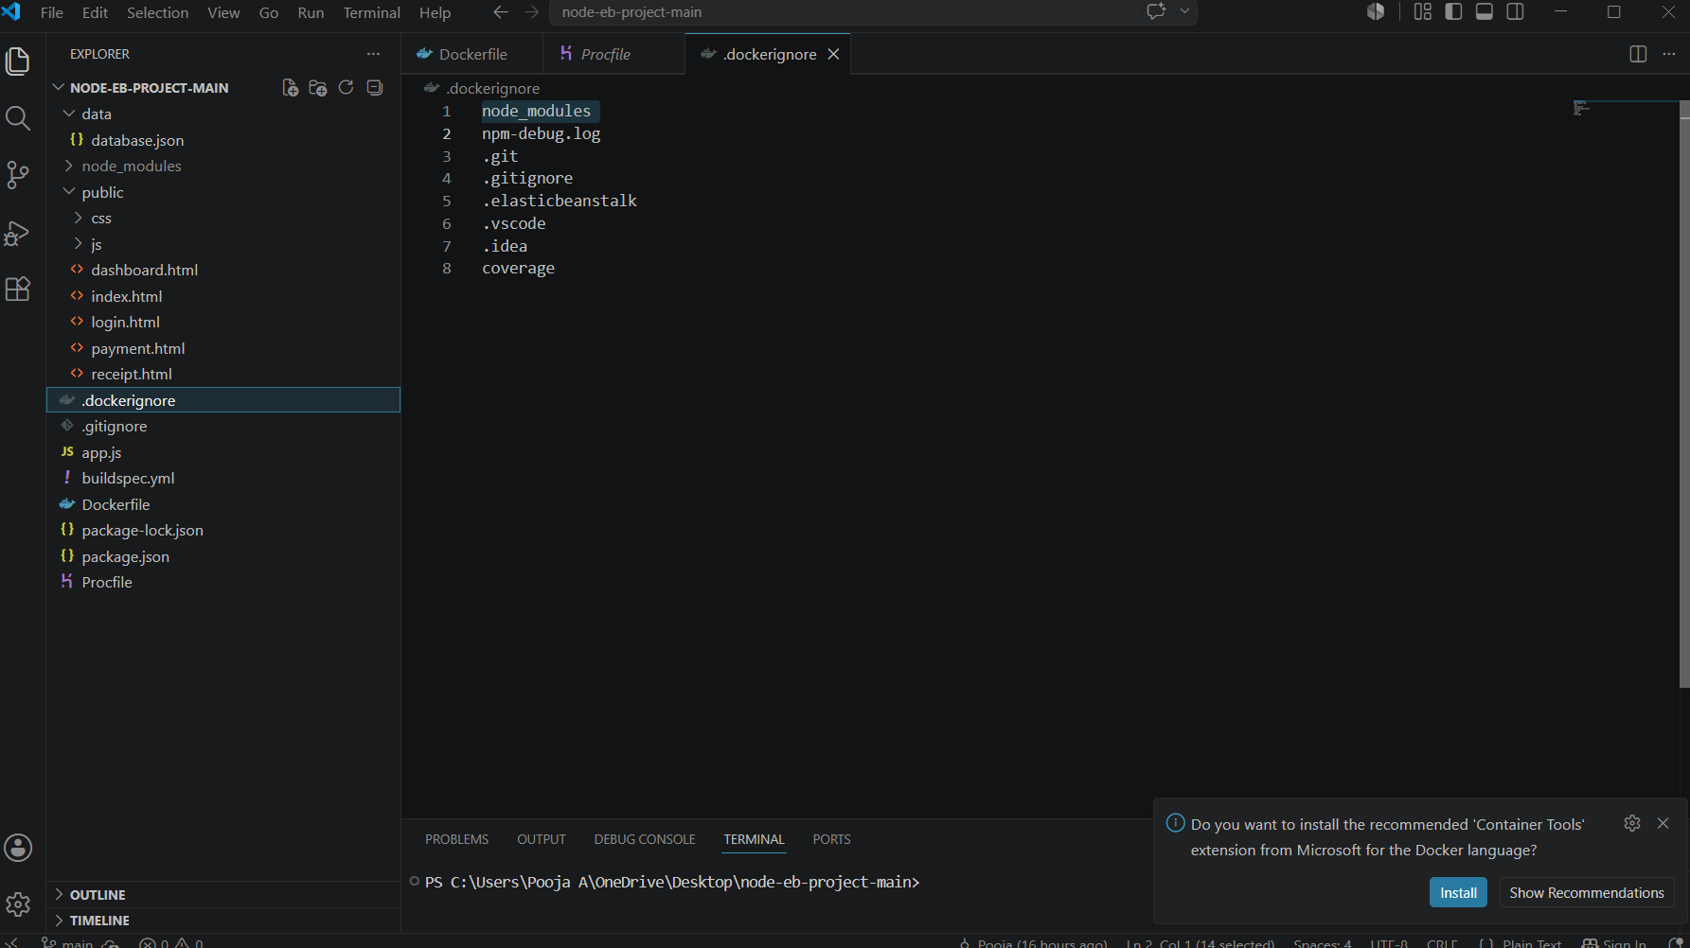
This reduced the Docker image size and improved the build process.
The following command was executed in the VS Code terminal: Step 4: Build the Docker Image
docker build -t travelgo .
This command created a Docker image named travelgo from the Dockerfile.
Step 6: Run the Docker Container
The following command was executed:
docker run -d -p 3000:3000 travelgo
This command created and started a Docker container from the travelgo image. Port 3000 of the container was mapped to port 3000 of the local machine.

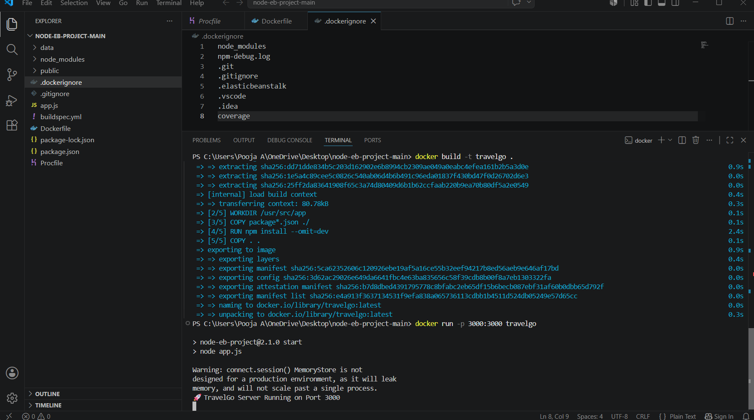
Step 7: Verify the Running Container The running container was verified using:
docker ps
The output confirmed that the travelgo container was running successfully.
Step 8: Test the Application
The application was accessed through: http://localhost:3000

The TravelGo application opened successfully in the browser.
Conclusion:
The TravelGo application was successfully developed and containerized using Docker. A Dockerfile and .dockerignore file were created to package and optimize the application. The Docker image was built successfully. The Docker image was built successfully, and the application ran inside a Docker container.

